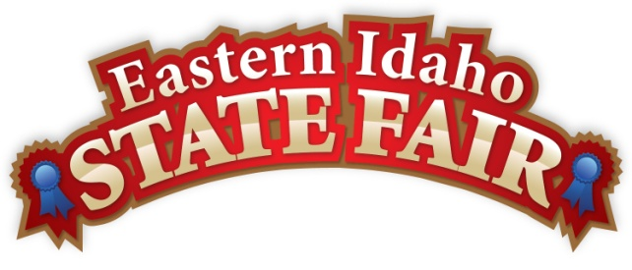
Media Contact
Brandon Bird
(208) 785-2480
brandon@funatthefair.com

FOR IMMEDIATE RELEASE

Scholarship for Graduating Idaho Seniors– Apply Now!
4-H and FFA Student Scholarship Deadline March 22

Blackfoot, ID (January 30, 2017) – The Eastern Idaho State Fair, in partnership with Butler Amusements, Inc., is pleased to offer six $1,000 scholarships to 2017 graduating seniors with a cumulative GPA of 3.0 or higher. Over the last twelve years these scholarships have been available, more than $60,000 has been awarded to local students.

In order to qualify, applicants must have participated in the 2016 Eastern Idaho State Fair as a 4-H or FFA member. In addition, recipients are chosen based on personal and professional goals, student activities, community service, honors and awards, and financial need. Students in the following counties of the 16 County District Fair are encouraged to apply: Bannock, Bear Lake, Bingham, Bonneville, Butte, Caribou, Clark, Custer, Franklin, Fremont, Jefferson, Lemhi, Madison, Oneida, Power, and Teton.

The deadline for applications is Wednesday, March 22, 2017. Applications must be mailed to the Eastern Idaho State Fair, P.O. Box 250, Blackfoot, ID 83221, or returned to the Main Office by 3pm on March 22. Please go to www.funatthefair.com for further instructions and to download applications. Call (208) 785-2480 or email cathy@funatthefair.com with any questions.

###

The Eastern Idaho State Fair is a 16 County Fair District. Over 230,000 people visit the annual event, making it Eastern Idaho’s longest running and largest community event. The mission of the EISF is to provide wholesome, affordable family education and entertainment in a clean and safe agricultural environment. It is never too early to get excited for next year’s fair, which will be held
September 1 – September 9th!

