2024 EISF
32 OZ SOUVENIR BOTTLE

A refillable souvenir beverage program will drive revenue and traffic to concessionaires.
Place your order by July 1st to purchase 32 oz. Souvenir Bottles directly from the Fair for best pricing.

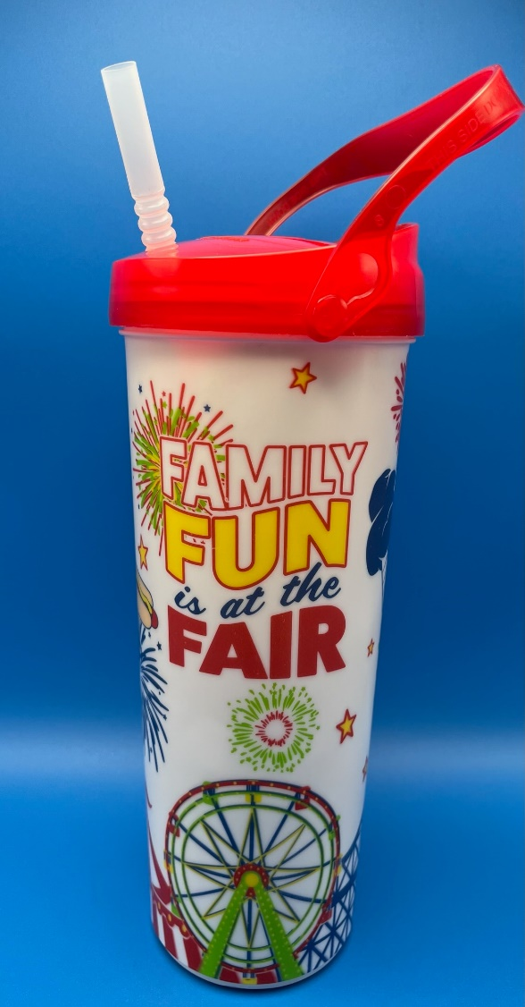
- Dishwasher safe bottle with handle is convenient for guests to carry - handles detach easily to hang on backpacks & strollers

- Drive repeat customers

- Fair will provide signage for concessionaires to use calling attention to refillable cup
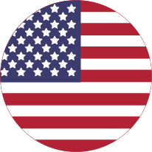
- Made in the USA

- Special Requirements: Must be the only refillable bottle concessionaires sell. Minimum order is (3) Cases – (80) bottles per case.

Request more information by emailing annmarie@funatthefair.com

2024 SOUVENIR BOTTLE
ORDER FORM

The Eastern Idaho State Fair is pleased to announce the 2024 Refillable Souvenir Bottle that can be sold by you as a concessionaire. The bottles will be purchased by the Fair and sold directly to the Concessionaire. In order to fill the demand for souvenir bottles for the upcoming Fair, please complete the order form below and return no later than July 1st to get the best pricing.

The Fair will be responsible for the design and purchase from dealer of the Souvenir Bottles. The bottle will be 32 oz., dishwasher safe, with the Eastern Idaho State Fair Logo and imagery. Bottle will come with handle, lid and straw and packed eighty (80) per case.

Price sold to the concessionaire by the Eastern Idaho State Fair will be $3 per bottle ($240 per case) and must be sold with pop to customers for $6. Refill prices can be set individually by concessionaires. Fair will provide signage for concessionaries to use calling attention to refillable bottle.

Number of cases ordered __________________

(80 bottles per case, includes lids, handles and straws)

You will be required to pay for all bottles by August 1st and picked up before August 23rd
unless other arrangements are made.

Fax: 208.785.2483 email annmarie@funatthefair.com
or mail form to EISF, PO Box 250, Blackfoot, ID 83221

Booth Name __________________________ Date ________________________________

Signature __________________________ Print Name __________________________

