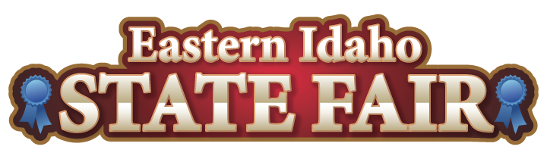13th Annual

BEST FAIR

FOOD AWARDS

ENTRY FORM

## **FOOD ENTRY FORM 2025**

*Send entry forms to:*

* *fax (208) 785-2483*
* *tickets@funatthefair.com*
* *PO Box 250, Blackfoot, ID 83221*

*Questions? (208) 785-2480*

Join us at this year's Fair as we crown the Concessionaires with the Best Fair Food. Our annual Best Fair Food Contest features four categories: Best Fair Food New Sweet Item, Best Fair Food New Entree, Fairest of them All Sweet, and Fairest of them all Entree. The competition will take place on Thursday, August 28, before the Fair. Concessionaires who want to participate must submit a completed entry form in writing by August 5. They can submit up to three food items, with a maximum of two items per category. Get ready to SADDLE UP! with the most delicious and innovative fair foods!

August 5: Written Entry Forms are due for all entries.

August 15: A panel of Fair Staff / Media will review all written entries, and the finalists will be notified.

August 28: 11:00 am to 1:00 pm Best Fair Food Competition

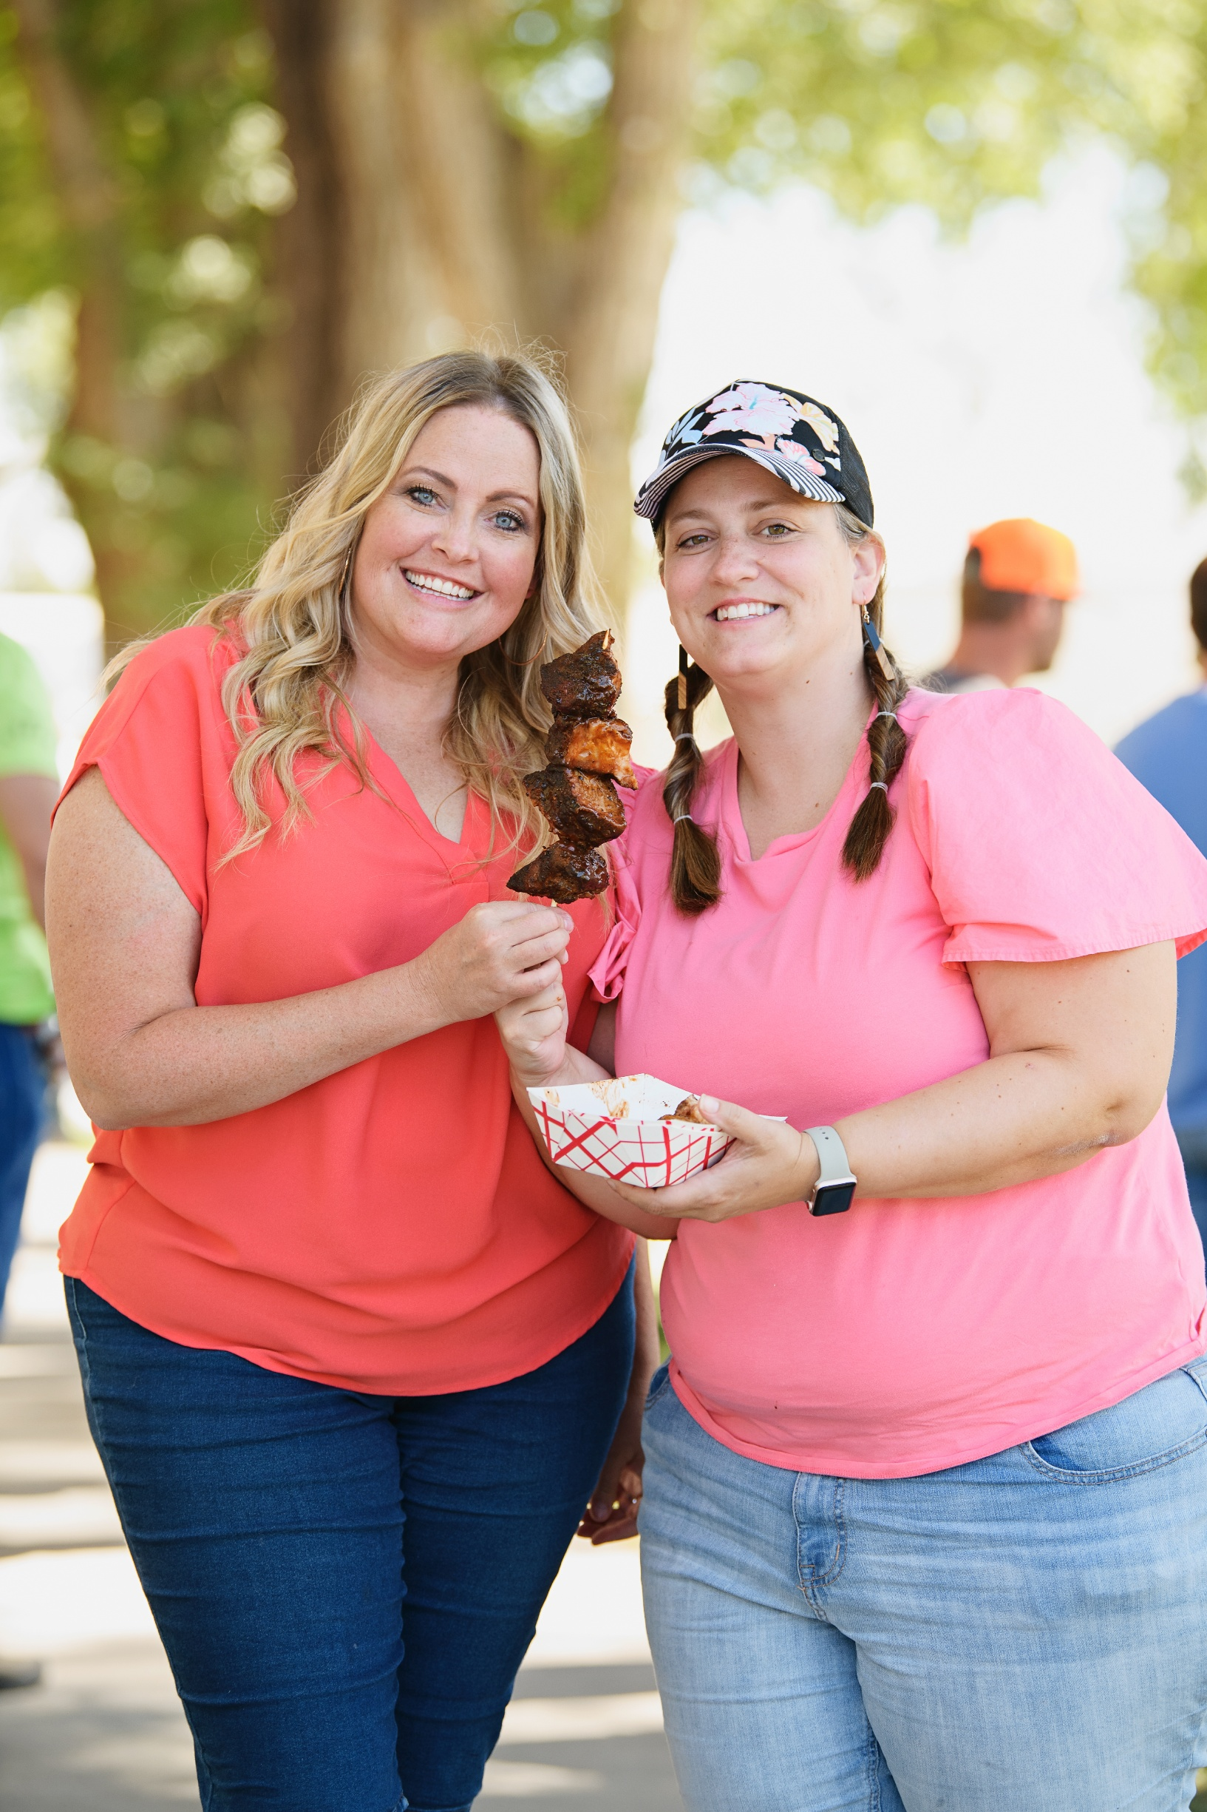

Concessionaire Information

Contracted Concessionaire Name: _____________________________________________________________________

Owner Operator / Authorized Representative: ­­­­­­ ___________________________________________________________

The best way we can reach you before the Fair: _________________________________________________________

How long have you been coming to the EISF as a vendor? __________________________________________________

Food Entry Information

**Official FOOD ENTRY Name (please only one entry per Entry Form):**

**__________________________________________________________________________________________________**

**Category: 🞏 BEST NEW SWEET ITEM (Added Incentive – See "Why Enter")**

**🞏** BEST NEW ENTREE (Added Incentive – See "Why Enter")

**🞏 FAIREST OF THEM ALL – SWEET**

**🞏** FAIREST OF THEM ALL - ENTREE

**This food item is served: 🞏 HOT 🞏 COLD 🞏 ROOM TEMP.**

**FOOD ENTRY Description: ____________________________________________________________________________**

**__________________________________________________________________________________________________**

**__________________________________________________________________________________________________To be considered for judging, FOOD ENTRY FORMS must be received by the EISF Office August 5 by 4:30 pm.  
Please submit a separate entry form for each food item.**

WHY ENTER

* All food items entered into the BEST OF THE FAIR FOOD contest will receive significant free promotion, creating a positive buzz among potential fair-goers.
* The winner in each category will receive an award that can be displayed on their concessionaire booth as the 2025 BEST OF winner for years to come.
* The winner in each category will be spotlighted on the Food Vendor Map in the Daily Schedule and on the website.
* The winner in the Best New Entree and Best New Sweet Item categories will receive $250 off the Concessionaire Percentage.

CATEGORIES

* BEST NEW ENTREE
* BEST NEW SWEET ITEM
* THE FAIREST OF THEM ALL – SWEET
* THE FAIREST OF THEM ALL - ENTREE

HOW TO ENTER

* Concessionaires must submit in writing a completed entry form with the name and description of the food item by August 5. Each concessionaire can *enter only 2 items* in each category, with a maximum of 3 total food items entered*. The finalists will be chosen based on the description of the food item – be creative!*

KEY DATES & TIMES

August 5: Written Entry Forms are due for all entries by 4:30 pm.

August 15: A Fair Staff / Media panel will review all written entries, and the finalists will be notified.

August 28: 11:00 am to 1:00 pm Food items judged and awarded by local media members.

RULES

1. All items entered must be food items on your menu for the 2025 Eastern Idaho State Fair.
2. Each concessionaire can enter only 2 items in each category with a maximum of 3 total food items.
3. Written entry forms must be received no later than August 5.
4. Concessionaires whose entries are selected for final judging will be notified on August 15.
5. Entries selected for tasting will be judged on August 28 from 11:00 am to 1:00 pm. Upon notifying the finalists, concessionaires will be advised of the exact time for judging each food item.
6. Those food items chosen from each category to be judged by the tasting panel will be required to provide 12-15 individual two-bite servings for tasting and one presentation dish.
7. Concessionaires are welcome to observe the TASTING JUDGING PANEL during the judging process.
8. No concessionaire is required to participate. However, it is highly recommended, given the positive publicity the participants will receive.
9. Categories may be combined if entries are low.

JUDGING

* A panel of up to 12-15 judges from Eastern Idaho Media Companies will be selected to judge the Best New Entrée, Best New Sweet Item, and Fairest of Them All.
* All items will be judged using Appearance, Taste, and Creativity.