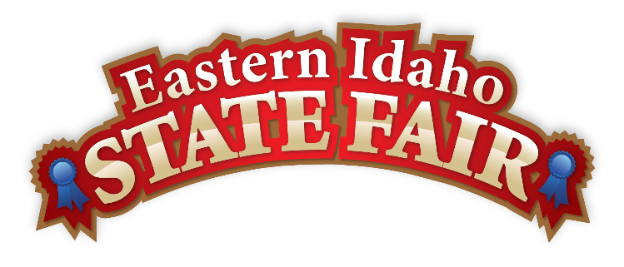
Media Contact
Brandon Bird
(208) 785-2480
brandon@funatthefair.com

FOR IMMEDIATE RELEASE

Eastern Idaho State Fair Announces 2025 Theme: Saddle Up
Nightly Grandstand Lineup Brings Big Names and Big Action to Blackfoot

BLACKFOOT, ID – April 15, 2025– Dust off your boots and tighten your cinch—because the Eastern Idaho State Fair is back and this year’s theme is a full-blown invitation to Saddle Up! From August 29 to September 6, 2025, fairgoers are in for nine rip-roarin’ days of entertainment, food, and fun that’ll have you hollerin’ “yee-haw!” all the way home.

This year’s Bank of Commerce Grandstand has a stampede of a lineup that’s bigger than a prairie sky. Whether you're into rodeos, wrecks, or rockstars, there's something for every kind of cowboy and cowgirl:
- August 29 – Country chart-topper Dylan Scott kicks things off with a boot-stompin’ concert
- August 30 – Hang onto your hats for the Bull Riding Championships
- August 31 – Feel the horsepower at the Western Truck & Tractor Pull
- September 1–3 – The Gem State Classic Pro Rodeo rides into town for three nights of world-class action
- September 4 – Comedy outlaw Jeff Dunham brings his posse of puppets for a wild night of laughs
- September 5 – Multi-GRAMMY winners Train take the stage with their chart-bustin’ hits
- September 6 – Wrap it all up with a bang at the September Slam Demolition Derby

Tickets are ONLY available at FunAtTheFair.com—so grab 'em before they high-tail it outta town.

In addition to the nighttime lineup, fairgoers can enjoy daytime attractions including the Indian Relay Races, Pari-Mutuel Horse Racing, livestock exhibitions, and culinary creations from hundreds of local vendors. Of course, it wouldn’t be the fair without the fried food, blue-ribbon livestock, belly-laughin’ attractions, and good ol’ family fun that’s been a tradition in these parts for 123 years.

“This year’s theme, Saddle Up, isn’t just about horses—it’s about takin’ life by the reins,” said Brandon Bird, Eastern Idaho State Fair General Manager. “We’re callin’ on everyone to show up, join the ride, and make memories worth their weight in gold.”

Don’t miss the chance to be part of Idaho’s biggest, boldest, and boot-kickin’est event of the year. For tickets, schedules, and event details, visit FunAtTheFair.com.

###

The Eastern Idaho State Fair is a 16-County Fair District. It is Eastern Idaho's longest-running and largest community event, with over 250,000 attendees each year. The mission of the EISF is to provide wholesome, affordable family education and entertainment in a clean and safe agricultural environment. It is never too early to get excited for the 2025 Fair, which will be held August 29 – September 6, 2025!

