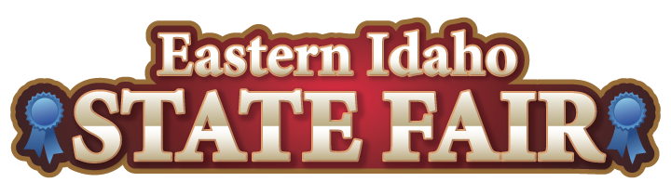
Media Contact
Brandon Bird
(208) 785-2480
brandon@funatthefair.com

FOR IMMEDIATE RELEASE
May 2024

Eastern Idaho State Fair & Butler Amusements Inc.
–2024 - 4-H/FFA Scholarships Announced

Blackfoot, ID - The Eastern Idaho State Fair continues to support outstanding high school seniors in Southeastern Idaho. In partnership with Butler Amusement, Inc., the Eastern Idaho State Fair announced the six scholarship winners, each of whom has been awarded a $1,000 scholarship to the college of their choice. Since its inception eighteen years ago, this scholarship fund has awarded over $112,000.00 to deserving college-bound teens.
The scholarship committee faced the challenge of selecting winners from a pool of commendable applicants. Each application was meticulously reviewed, a testament to the exceptional quality of our youth and the 4-H and FFA Programs in Southeastern Idaho that nurture their talents. As Board Chairman Corey Foster aptly puts it, "Reviewing the outstanding scholarship applications gets more difficult each year; our youth are amazing, and the 4-H and FFA Programs in Southeastern Idaho cultivate the best".
The six finalists were selected based on past years' experience in FFA or 4-H and their personal and professional goals, honors, activities, community service, and financial need. The winners are Hope Wanstrom, Bingham County, Firth High School; Jamie Sherman, Madison County, Madison High School; Lucy Barney, Jefferson County, Rigby High School; Cooper Hatch, Bingham County, Blackfoot High School; Hadley Ashby, Franklin County, West Side High School; and Hadley MacConnell, Butte County, Idaho Virtual Academy. The six scholarship winners and their families were invited to attend a special dinner in their honor with the Eastern Idaho State Fair Board of Directors and staff on Thursday, April 25, 2024.
The 2025 Scholarship is open to all graduating seniors from the 16 surrounding counties. We encourage all those interested to apply. Applications will be available beginning on January 1, 2025.
###
The Eastern Idaho State Fair is a 16-County Fair District. The Fair celebrates 122 years as Eastern Idaho's longest running and largest community event, with nearly 255,000 attendees each year. The mission of the EISF is to provide wholesome, affordable family education and entertainment in a clean and safe agricultural environment. It is never too early to get excited for the 2024 Fair, August 30 – September 7, 2024!

Butler Amusements, Inc., was started 50+ years ago and is now the largest carnival company in the Western United States, providing carnivals for over 116 different Fairs and events each year. Butler operates over 120 amusement rides in seven western states, including California, Oregon, Washington, Idaho, Nevada, Arizona and Texas. Butler strives to produce affordable family entertainment for its patrons and considers it a privilege to offer attractions that bring joy and happiness to all ages.

