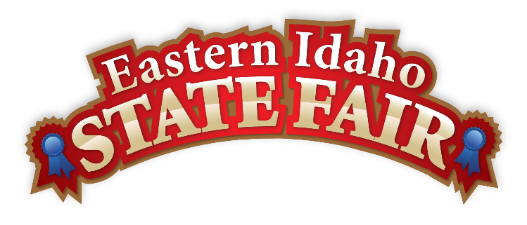
Media Contact
Brandon Bird
(208) 785-2480
brandon@funatthefair.com

FOR IMMEDIATE RELEASE

Gene and Marietta Womack Named 2025 Grand Marshals of the Eastern Idaho State Fair
Blackfoot, ID – July 2025 – The Eastern Idaho State Fair is proud to announce Gene and Marietta Womack as the 2025 Grand Marshals. Known for their selfless service and unwavering community spirit, the Womacks have been selected to lead this year's festivities in recognition of their decades-long dedication to the fair, their fellow veterans, and their hometown of Blackfoot.
This honor marks a moment in fair history—selecting a duo whose partnership in service is as strong as their bond in life. From military deployments to local traditions, Gene and Marietta have quietly shaped the character of the fair through years of behind-the-scenes work—particularly in the American Legion Beer Garden, where they've fostered a space full of warmth, welcome, and camaraderie.
Gene's journey of service began during the Korean War era, enlisting in the National Guard while still in high school. Over the next 26 years, he served in the Army Reserves, Navy Seabees, and again in the Reserves—building bridges, training troops, and forming an Honor Guard at the American Legion Stewart Hoover Post to honor fallen veterans.
By his side through it all, Marietta balanced family life with steadfast support, standing strong during deployments, career changes, and countless volunteer hours. Together, they've become pillars of the fair's American Legion presence—creating not just a spot to relax, but a lasting symbol of community pride.
"Gene and Marietta represent everything the fair is about—hard work, heart, and homegrown values," said Brandon Bird, General Manager of the Eastern Idaho State Fair. "They don't seek the spotlight, but they deserve it. Honoring them as Grand Marshals is our way of saying thank you for years of quiet dedication."
Gene and Marietta will lead the Grand Parade this September and take their place at the forefront of the 2025 Fair—reminding us all that the soul of the fair lies not in the midway, but in the people who make it matter.
For more information about the Eastern Idaho State Fair and upcoming events, visit www.funatthefair.com.

###

The Eastern Idaho State Fair is a 16-County Fair District. It is Eastern Idaho's longest-running and largest community event with over 250,000 attendees each year. The mission of the EISF is to provide wholesome, affordable family education and entertainment in a clean and safe agricultural environment. It is never too early to get excited for the 2025 Fair, which will be held August 29 – September 6, 2025!

