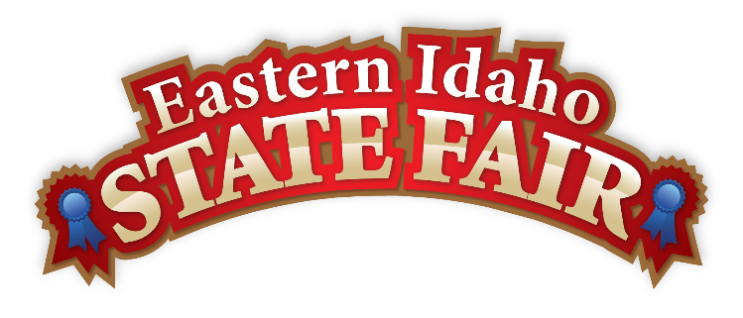
Media Contact
Brandon Bird
(208) 785-2480
brandon@funatthefair.com

FOR IMMEDIATE RELEASE

Eastern Idaho State Fair Welcoming Exhibitors

BLACKFOOT, ID – August 22, 2024 – The Exhibitor Handbook for the 2024 Eastern Idaho State Fair is now accessible exclusively online for your convenience. It contains all the rules, entry forms, and requirements for entering Livestock, Home Arts, or Special Competitions.

The link to the 2024 Exhibitor Handbook is www.funatthefair.com/exhibitors-and-competitors

Entry dates for Home Arts vary from August 23-29. Please check each specific department Exhibitor Book to get entry dates and times.

Aug 23-24 Antiques, Fine Arts, Photography, Hobbies and Crafts, and Needlecraft
Aug 26 Native American entries received at Tribal Office
Aug 27-28 Native American entries received at Fairgrounds
Aug 27 Sugar Art and Baking and Canning
Aug 28 – 29 Flowers and Agriculture and Horticulture Aug 29

While Livestock entries were due by Aug 16, call the livestock office at 208.269.7027 to see if your department can still accept entries.

FIRST-TIME EXHIBITORS: Are you a first-time Exhibitor who wants to enter items for the 2024 Fair – go to www.funatthefair.com/exhibitors-and-competitors for answers to the most asked questions that will help you get on your way to becoming a seasoned novice! Entering at the Fair is a blue ribbon experience you don’t want to miss!

The Fair has always been the event where there is MORE of the things you love. See you at the Fair Aug 30 to Sept 7 for MORE FUN!
###

The Eastern Idaho State Fair is a 16-County Fair District. It is Eastern Idaho's longest-running and largest community event with over 250,000 attendees each year. The mission of the EISF is to provide wholesome, affordable family education and entertainment in a clean and safe agricultural environment. It is never too early to get excited for the 2024 Fair, which will be held August 30-September 7!

