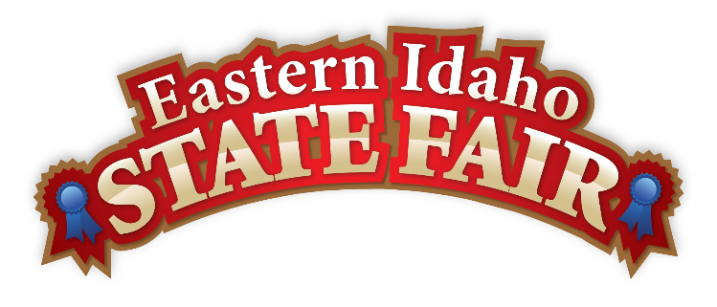
Media Contact
Brandon Bird
(208) 785-2480
brandon@funatthefair.com

FOR IMMEDIATE RELEASE

2025 SCHOLARSHIP WINNERS ANNOUNCED

The Eastern Idaho State Fair, in partnership with Butler Amusements, Inc., is thrilled to continue its support for local high school seniors by offering six scholarships to students graduating in 2025. For the first time in the nineteen-year history of this scholarship program, we are excited to announce an increase in the award amount from $1,000 to $1,500 for each winner. The Fair's commitment to agricultural education and youth programs is demonstrated by the $120,000 in college scholarships awarded since the program's inception.

This year's scholarship selection was especially challenging for the committee, with applicants representing nearly all 16 counties. "The youth participating in the Eastern Idaho State Fair events are crucial to preserving the hometown commitment that we value," said Dennis Marshall, Board of Director Chairman.

These scholarships are awarded to graduating seniors who have participated in and supported 4-H and FFA at the Eastern Idaho State Fair for a minimum of three years. The recipients for 2025 have significantly surpassed this requirement, collectively amassing 46 years of participation in fair events, making their counties proud!

This year's scholarship recipients are:
- Alivia Waldron, Oneida County, Malad High School
- Eliana Cecil, Butte County, Cornerstone Academy
- Jade Kelly, Bonneville County, Shelley High School
- Jailey Jones, Bannock County, Marsh Valley High School
- Jason Fleming, Madison County, Sugar Salem High School
- Lydia Hamilton, Caribou County, Grace High School

The scholarship winners and their families were invited to a special dinner in their honor with the Eastern Idaho State Fair Board of Directors and staff on Wednesday, April 23, 2025.

Looking ahead, the 2026 scholarship will be available to all graduating seniors from the 16 surrounding counties. We encourage all interested students to apply; applications will be available starting January 1, 2026.

For more information about the Eastern Idaho State Fair, please visit www.funatthefair.com.

###

The Eastern Idaho State Fair is a 16-County Fair District. It is Eastern Idaho's longest-running and largest community event, with over 250,000 attendees each year. The mission of the EISF is to provide wholesome, affordable family education and entertainment in a clean and safe agricultural environment. It is never too early to get excited for the 2025 Fair, which will be held August 29 – September 6, 2025!

