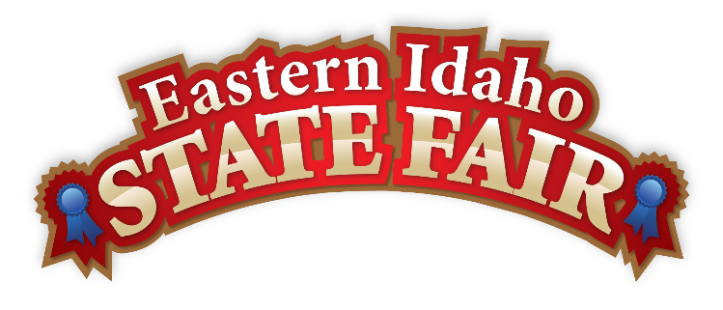
Media Contact
Brandon Bird
(208) 785-2480
brandon@funatthefair.com

FOR IMMEDIATE RELEASE

Eastern Idaho State Fair Announces 2025 Friend of the Fair Award Recipients
Blackfoot, ID – August 2025 – BLACKFOOT, Idaho – The Eastern Idaho State Fair is proud to announce the recipients of the 2025 Friend of the Fair Awards, recognizing individuals who have made extraordinary contributions to the fair and the Eastern Idaho community.
This year's honorees are Val and Gail Chambers, Steven Butler, and Donnie Wheeler. The Friend of the Fair Award represents the highest honor bestowed by the Eastern Idaho State Fair, celebrating those who have demonstrated exceptional dedication, service, and support for the Fair's mission and values.
Val and Gail Chambers have been pillars of the Eastern Idaho community, contributing countless hours and unwavering support to the 4-H Program over many years. The Madison County residents are the parents of Gem State Classic Pro Rodeo Superintendent Valorie Blanchard and raised three children who were heavily involved in 4-H programs. Val has judged numerous 4-H horse shows and takes great joy in watching young participants advance and grow over the years. The Chambers credit 4-H with helping their children become responsible and respectful individuals who have learned to work with all kinds of people. Their dedication to preserving agricultural traditions and supporting local youth through 4-H and FFA programs has left an indelible mark on generations of fairgoers. When attending the fair, you can find them enjoying their favorite treat – the Prime Rib Sandwich at Billman's BBQ.
Steven Butler, who passed away in February 2025, will be honored posthumously for his remarkable 20-year service to the Eastern Idaho State Fair as a beloved Gate Person. Steve was known for his friendly demeanor, having a kind word for everyone, and his remarkable ability to remember fairgoers by name year after year. His wife remembers him as "the biggest sweetheart and absolute best husband, dad, and grandpa." The couple was married for 41 years and 7 months, having become engaged on July 4, married on July 13, and moved to Houston on July 22. Steve's favorite fair food was from BJ's Bayou, and his warm presence at the fair gates will be deeply missed by the countless visitors whose days he brightened with his welcoming spirit. Steve exemplified the countless dedicated individuals who pour their hearts into the Fair each year, making it an unforgettable experience for all.
Donnie Wheeler, also being honored posthumously after passing in December 2024, dedicated significant time and energy to supporting the Fair's mission through his deep involvement in the agricultural and western heritage community. Known professionally as Elvin Don Wheeler, he was a lifelong horseman who worked as a horse trainer across Idaho, Montana, and Wyoming, and spent years as a farrier after learning to shoe horses early in his career. For 30 years, Don was the distinctive voice behind the Indian Relay Races as well as horse racing at the fair, bringing unmatched excitement and expertise to these thrilling events. He loved the excitement of close races and often remarked that "no one comes to the fair for the flat track, they come for the excitement of the Indian Relay Races." Don got started in the business as an auctioneer, where he learned the technique of his booming voice – oftentimes, people wouldn't recognize him until he opened his mouth to talk. Instead of going to college, he chose to pursue trades, with auctioneering, corrective horseshoeing, rodeo announcing, and horse training as his career paths. But for Don, it wasn't work – he enjoyed every second of it. He could often be seen in the announcer booth with his favorite fair food, a Tiger's Ear. Don was actively involved in numerous organizations, including the Rigby Chariot Association, All American Cutter Association, Bonneville Chariot Association, National Cutter Association, and Jefferson County Posse, serving as President of the WCC and CRA for many years. His commitment to the community and the agricultural heritage of Eastern Idaho, combined with his lifelong dedication to horses and western traditions, exemplified the spirit of volunteerism that makes the fair possible.

"These four individuals represent the good, hardworking people found within our community," said Brandon Bird, General Manager of the Eastern Idaho State Fair. "Their selfless service, dedication, and love for the Eastern Idaho State Fair have helped shape our event into what it is today. We are honored to recognize their contributions with this special award."

The Friend of the Fair Awards will be presented at the 2025 Eastern Idaho State Fair, which will take place from August 29 to September 6, 2025, in Blackfoot, Idaho. The theme for the 2025 Fair is "Saddle Up!"

Established in 1902, the Eastern Idaho State Fair welcomes over 250,000 visitors each year and celebrates the agricultural heritage, community spirit, and family traditions of Eastern Idaho.

For more information about the Eastern Idaho State Fair and upcoming events, please visit www.funatthefair.com.
###

The Eastern Idaho State Fair is a 16-County Fair District. It is Eastern Idaho's longest-running and largest community event with over 250,000 attendees each year. The mission of the EISF is to provide wholesome, affordable family education and entertainment in a clean and safe agricultural environment. It is never too early to get excited for the 2025 Fair, which will be held August 29 – September 6, 2025!

