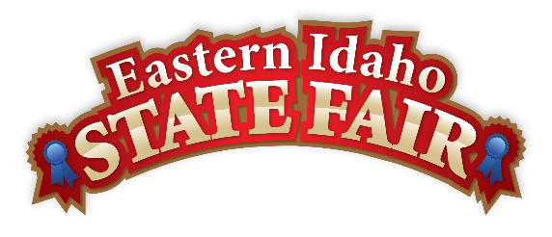

All Applicants:

Thank you for your interest in booth space at our next Eastern Idaho State Fair to be held
September 4 – 12, 2026 a 9-day fair. We are always on the lookout for exciting new products.

- In order to consider your company or product, please complete the enclosed Application for Concession/Commercial Space and return it with brochures and photographs of your product and booth set-up. Your application will not be considered without this information.

The Eastern Idaho State Fair is a 16 County Fair District. Over 250,000 people visit the annual event, making it Eastern Idaho’s longest running and largest annual community event. The mission of the EISF is to provide wholesome, affordable family education and entertainment in a clean and safe agricultural environment.

The Eastern Idaho State Fair endeavors to maintain a variety of products on the Fairgrounds and strives to avoid duplications of products. Every company or individual doing business on the Eastern Idaho State Fairgrounds must have a written and signed contract with regard to this activity, which will list the approved items to be sold and displayed. All exhibitors are expected to have someone working in their booth during the specified hours:

10 A.M. - 10 P.M. September 4 – 12, 2026

Please do not send money with the application. If an exhibit space becomes available that will fit your needs, you will be contacted. If not, we will send you notice to see if you would like us to hold your application for exhibit space in 2027.

If you have any questions, please contact the fair office at (208) 785-2480.

Sincerely,

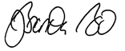
Brandon Bird
Manager
Enc: Application for Space



EXHIBITOR SPACE APPLICATION
Please Mail Application to: PO BOX 250 - BLACKFOOT, ID 83221 or - Fax: (208) 785-2483 or Email: thefair@funatthefair.com

FAIR DATES: September 4 - 12, 2026 APPLICATION DATE

NAME OF FIRM:
CONTACT NAME:
(Name of person who will run your operation at the Fair)
MAILING ADDRESS:
CITY/STATE/ZIP: _____________________________________________________________E-MAIL ADDRESS:
BUSINESS PHONE: ________________________________ HOME PHONE: _________________________________ CELL PHONE:

NAMES OF ALL PERSONS, DISTRIBUTORS, OR COMPANIES HAVING AN OWNERSHIP/INTEREST IN THIS EXHIBIT:
Do you, any other person, distributor or company having an interest in the exhibit have an interest in any other exhibit/concession, ride, attraction, show or department at the EASTERN IDAHO STATE FAIR? Yes No If YES, please explain

Name and describe ALL items to be sold, exhibited and/or demonstrated. Gifts, novelties, and craft items must be SPECIFICALLY and INDIVIDUALLY listed. “Crafts” or “Novelty items” is not acceptable. If approved for booth, your contract will state that ONLY those items listed here can be sold from your booth. If you are providing a service or handing out information, please explain exactly what you will offer. If you need more space, please enclose a separate piece of paper to describe your items or services offered.

ELECTRICAL REQUIREMENTS other than single 110 volt 15 amp plug
SPACE/AREA SIZE DESIRED:
INDOOR OUTDOOR 10’X10’ 12’X15’ FRONTAGE____________ DEPTH ________________

THE APPLICANT UNDERSTANDS THAT THIS IS AN APPLICATION FOR EXHIBIT SPACE ONLY AND IS NOT A SPACE RENTAL CONTRACT WITH THE EASTERN IDAHO STATE FAIR.

Please list (3) three References:

Fair/Event: Name: Phone:

Fair/Event: Name: Phone:

Fair/Event: Name: Phone:

In order to consider your company or product, please return application with brochures and photographs of your product and booth set-up. Your application will not be considered without this information.

SIGNATURE OF APPLICANT_______________________________________________________ DATE_______________________________________________

do Not send money with this application

BLACKFOOT, IDAHO
RENTAL SCHEDULE - 2026

ALL PRICES ARE SUBJECT TO CHANGE
Please do not send this sheet back with application,
this is for your information only.

BUILDING/LOCATION SIZE APPROXIMATE COST

Commercial - Inside Space

Merchants Square Building #6 12'x15' $800.00
The Bazaar Building #7 10'x10' $725.00
Harvest Place Building #8 12'x15' $675.00

Commercial - Outside Space

Blue Ribbon Boulevard 10'x10' $850.00
State Fair Circle 20'x20' $600.00
Market Plaza Footage and prices to be determined as needed

Concession Space

Food Court or Candy Apple Alley 15% of Gross Sales

