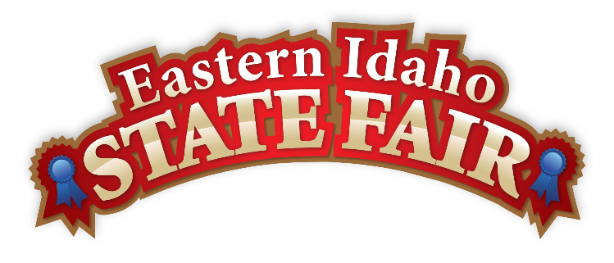
Media Contact
Brandon Bird
(208) 785-2480
brandon@funatthefair.com

FOR IMMEDIATE RELEASE

123rd Eastern Idaho State Fair Opens Its Gates for Another Year of Family Fun and Community Celebration
BLACKFOOT, IDAHO – The Eastern Idaho State Fair is excited to announce the kickoff of its 123rd annual celebration, bringing together families, friends, and communities from across the region for days of unforgettable entertainment, agriculture exhibits, delicious food, and time-honored traditions. This year's fair promises to deliver the perfect blend of classic fair experiences and exciting new attractions, creating lasting memories for visitors of all ages. The Fair invites everyone to Saddle Up and enjoy this time-honored tradition!

Evening Grandstand Entertainment
The Fair's renowned evening grandstand shows will once again be a major highlight, featuring an incredible lineup that promises something for everyone under this year's "Saddle Up" theme.
Friday, August 29 at 7:30 PM – Dylan Scott with Due West Multi-platinum country recording artist Dylan Scott kicks off the Fair with his powerhouse vocals and chart-topping hits. With four No. 1 singles, including "My Girl," "Nobody," "New Truck," and the viral sensation "Can't Have Mine (Find You A Girl)," Scott brings his deep Southern drawl and heartfelt songwriting to Blackfoot. Having toured with country legends like Garth Brooks, Luke Bryan, and Chris Young, this Louisiana native has earned over 4 billion career streams and is one of country music's fastest-rising stars.
Saturday, August 30 at 7:30 PM – Bull Riding Championships Hold onto your hats for the "most dangerous eight seconds in sports." Watch skilled riders attempt to stay atop whirlwinds of chaos using only one hand to hold on. This hair-raising competition showcases the fine art of bull riding, where contestants face flailing hooves, horns, and pure adrenaline in what promises to be a wild night of entertainment.
Sunday, August 31 at 7:30 PM – Western Truck & Tractor Pull Nationals Experience the power and excitement as the best truck and tractor pulling vehicles from across the Western U.S. compete in this high-energy spectacle. From 10,000+ horsepower multi-engine tractors to ground-pounding super modified pickups, this "Highest Energy, Highest Paced" tractor pull series will keep audiences on the edge of their seats with nonstop action.
Monday, September 1-3 at 7:30 PM – Gem State Classic Pro Rodeo The two-time PRCA Small Market Rodeo of the Year returns for three consecutive nights of world-class rodeo action. This beloved tradition brings authentic Western culture to life with thrilling competitions that showcase the skill, tradition, and heart-stopping excitement that rodeo fans crave.
Thursday, September 4 at 7:30 PM – Jeff Dunham Global comedy sensation Jeff Dunham brings his wildly popular "Still Not Canceled Tour" to Blackfoot. With over 7.7 million fans attending more than 1,500 shows worldwide, Dunham has become one of the most successful comedians on the planet. His unforgettable characters and razor-sharp humor have earned him record-breaking specials on Comedy Central and Netflix, with nearly 2.5 billion views across digital and TV platforms.
Friday, September 5 at 7:30 PM – Train with Edwin McCain Close out the fair with an incredible night of live music featuring Grammy Award-winning pop band Train, accompanied by special guest Edwin McCain. This powerhouse combination promises an unforgettable evening of hit songs and musical excellence.
These evening shows have become a beloved tradition, drawing crowds who gather under the stars to enjoy world-class entertainment in an authentic Idaho setting.

New Interactive Kids' Mural Debuts
This year, the Fair is proud to introduce an exciting new addition for young visitors: a large interactive mural located behind the grandstands where children can unleash their creativity. This colorful new attraction provides a perfect opportunity for kids to contribute to the Fair's vibrant atmosphere while developing their artistic skills.

A Rich Heritage Continues
For 123 years, the Eastern Idaho State Fair has served as a cornerstone of the community, celebrating the region's agricultural heritage while embracing modern entertainment and family fun. Visitors can expect all the traditional fair favorites, including livestock exhibitions, 4-H competitions, carnival rides, games, and an incredible variety of food vendors serving everything from classic fair treats to local specialties.
"We're thrilled to welcome everyone back for our 123rd year," said Brandon Bird, EISF General Manager. "This year's Fair represents the perfect combination of honoring our agricultural roots and providing new, exciting experiences for families. The new kids' mural is just one example of how we continue to evolve while maintaining the community spirit that makes our fair special."

Fair Information

Dates: Friday, August 29th through Saturday, September 6th
Admission: Eastern Idaho State Fair Ticket Pricing
Adult Gate (Ages 12 & up)
- Advance Purchase (ends August 28): $8
- Fair Week: $9
Youth Gate (Ages 6-11)
- Advance Purchase: $5
- Fair Week: $6
Child Gate (Ages 5 & under)
- Free admission
Senior Gate (Ages 65 & up)
- Advance Purchase: $6
- Fair Week: $7
Pepsi Wristband
- Includes: Gate admission PLUS unlimited carnival rides for one full day
- Valid on: Tuesday, Wednesday, OR Thursday only
- Price: $32 (same price advance or fair week)
Carnival Wristband
- Includes: Unlimited carnival rides for any one day
- Does NOT include gate admission (must purchase separately)
- Advance Purchase: $30
- Fair Week: $40
Individual Ride Tickets
- Each ride requires 4-7 tickets
- Only available during fair week: $1 per ticket
Ultimate Happy Pass
- Includes: Entire week's fair admission AND horse races
- Price: $50
Note: Grandstand evening events when purchased include gate admission.
For a complete schedule of events, entertainment lineup, and ticket information, visit www.funatthefair.com or follow the Eastern Idaho State Fair on social media.
###

The Eastern Idaho State Fair is a 16-County Fair District. It is Eastern Idaho's longest-running and largest community event with over 250,000 attendees each year. The mission of the EISF is to provide wholesome, affordable family education and entertainment in a clean and safe agricultural environment. It is never too early to get excited about the 2025 Fair, which will be held from August 29 to September 6, 2025!

