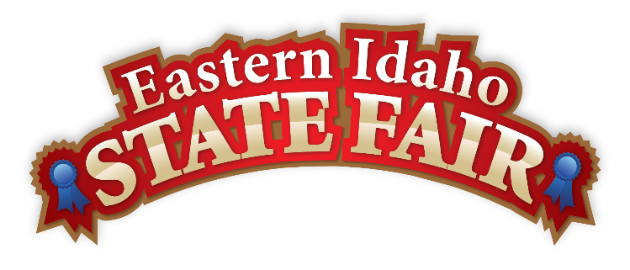
Media Contact
Brandon Bird
(208) 785-2480
brandon@funatthefair.com

FOR IMMEDIATE RELEASE

2025 Eastern Idaho State Fair Saddled Up to Another Successful Year

BLACKFOOT, ID – September 15, 2025 – The 2025 Eastern Idaho State Fair has just ended, marking another successful year filled with unforgettable moments as visitors were invited to SADDLE UP to the annual Fair. The extraordinary event that captivated visitors and left lasting memories was attended by 254,555 people, just slightly below the record-setting year of 2024.

The EISF would like to thank Grand Champion Sponsors, Bingham Healthcare and Teton Auto Group, for their continued support and dedication. The Bank of Commerce also proudly sponsored the Grandstand Arena, where enthusiastic fans gathered to enjoy performances by country music star Dylan Scott, comedian Jeff Dunham, and the rock band Train. Their incredible shows were among the highlights of this year's entertainment lineup, drawing crowds from all over Idaho and beyond.

This year's Fair continued to build on past successes with three nights of the Gem State Classic Pro Rodeo, a two-time Small Market Rodeo of the Year by PRCA. The Bank of Commerce Grandstand Arena also hosted fan-favorite events, such as the Western Truck and Tractor Pulls, the Bull Riding Championships, and the always sold-out September Slam Demolition Derby. Daytime in the Bank of Commerce Grandstand was full of action with the National Indian Relay Championship going to the local favorite, TETON TEAM! Parimutuel Horse Racing was also full of action, featuring its best card of races in the last ten years. The quality of those horses was evident, as evidenced by three track records set on different days.

During nine consecutive days of great weather, many from the five-state region attended, increasing Blackfoot's population by over 250,000 for the nine days of fun! Once again, fair food took center stage with new and delicious offerings. This year's Fair Food Contest winners included La Quesabirra from La Casita Mexican Food, taking top honors for Best New Entrée, while the Campfire Secret from Sweet Temptations won Best New Sweet. The returning favorites also impressed, with Crazy Corn Nachos from Mexican Crazy Corn claiming the Fairest Entrée of Them All, and Peachy Keen from Camille's Crepes winning Fairest Sweet of Them All. The People's Choice award went to The Warhawk from Blackhawk BBQ. Attendees were impressed by the unique and creative entries that have excited Fair Foodies.

In keeping with tradition, this year's Kick-Off Parade featured numerous marching bands, floats, and entries to open the Fair officially.
This year's Grand Marshal recognition was awarded to Gene and Marietta Womack, longtime supporters of the Fair and community leaders. They were honored for their contributions to the agricultural community and unwavering dedication to the Fair, embodying the Fair's long-standing values of family, tradition, and community spirit.

The Fair Board's commitment to growing its livestock competitions culminated near the end of the week with the 4-H Livestock Sale, where tens of thousands of dollars were raised for Eastern Idaho Youth in 4-H. "The livestock side of our competitions are an integral part of what we do at the Fair. Our mission is to provide wholesome, affordable family education and entertainment in a safe agricultural environment, and livestock competitions are integral to that mission," said Dennis Marshall, Board Chairman from Bonneville County.

"Every year, dedicated concessionaires, enthusiastic vendors, generous sponsors, skilled contractors, and our hardworking team of Fair employees unite to create an extraordinary event that captivates visitors and leaves lasting memories. Their invaluable contributions propel the Fair's success," expressed Brandon Bird, General Manager. "With great anticipation for the upcoming year, we are thrilled to be planning a spectacular lineup of world-class entertainment, exhilarating competitions, and unforgettable experiences designed to engage and delight everyone who joins us."
Mark your calendars for the 2026 Eastern Idaho State Fair from Sept 4-12, 2026.

For more information about the Eastern Idaho State Fair, please visit www.funatthefair.com.

###

The Eastern Idaho State Fair is a 16-County Fair District. It is Eastern Idaho's longest-running and largest community event, attracting over 250,000 attendees annually. The mission of the EISF is to provide wholesome, affordable family education and entertainment in a clean and safe agricultural environment. It is never too early to get excited for the 2026 Fair, which will be held from September 4 to 12, 2026!

