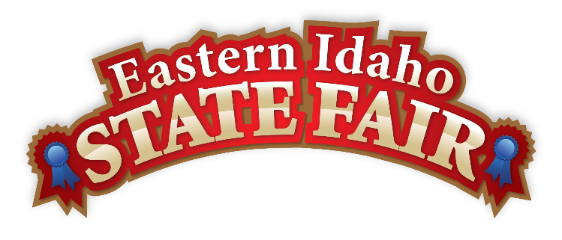
Media Contact
Brandon Bird
(208) 785-2480
brandon@funatthefair.com

FOR IMMEDIATE RELEASE

Gem State Classic Pro Rodeo Earns Back-to-Back PRCA Top 5 Honors
Blackfoot, ID – October 2025 – The Gem State Classic Pro Rodeo has once again received national recognition, earning a coveted spot as a PRCA Top 5 Medium Market Rodeo for the second consecutive year. Held annually at the Eastern Idaho State Fair, this standout event continues to shine as a premier destination for rodeo excellence.
Dennis Marshall, Chairman and Board Director of the Eastern Idaho State Fair, shared his appreciation: "We owe it all to the world-class rodeo contestants whose talent and grit make our event truly exceptional. A heartfelt thank you goes out to our generous Sponsors, dedicated Stock and Production Contractors, passionate rodeo fans, and the tireless Rodeo Committee Volunteers. Your support and commitment make this recognition possible. We couldn't do it without you!"
Now in its 14th year, the Gem State Classic has already earned two PRCA Small Market Rodeo of the Year titles, and its continued rise reflects the strength of Idaho's rodeo spirit. PRCA members will cast their votes for the Top Rodeos in each category from October 28–31, with winners announced at the PRCA Awards Banquet at the South Point in Las Vegas on December 3 at 6 p.m. PT.
Rodeo Superintendent Valorie Blanchard added, "The Gem State Classic Pro Rodeo continues to raise the bar for rodeo entertainment. With strong partnerships, exceptional livestock, and the unwavering support of the PRCA and its athletes, the Eastern Idaho State Fair is proud to represent Idaho on the national rodeo stage."
For more information about the Gem State Classic Pro Rodeo and the Eastern Idaho State Fair, visit www.funatthefair.com.

###

The Eastern Idaho State Fair is a 16-County Fair District. It is Eastern Idaho's longest-running and largest community event with over 250,000 attendees each year. The mission of the EISF is to provide wholesome, affordable family education and entertainment in a clean and safe agricultural environment. It is never too early to get excited for the 2026 Fair!

