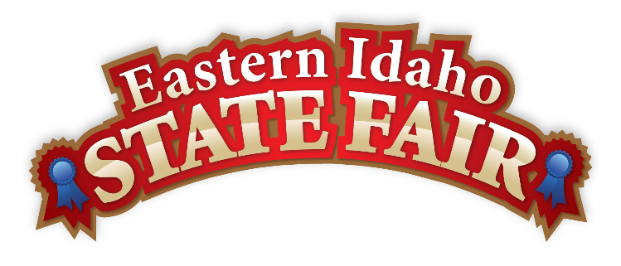
Media Contact
Brandon Bird
(208) 785-2480
brandon@funatthefair.com

FOR IMMEDIATE RELEASE

EISF names Leo Teton as 2021 Grand Marshal

BLACKFOOT, ID – July 14, 2021 - When Eastern Idaho State Fair Manager, Brandon Bird, called Leo Teton to ask if would accept the honor of being the Grand Marshal of the 2021 EISF, Teton told him he needed to think about it. This falls right in line with the humble nature of this accomplished man. He did choose to accept and Leo Teton officially became the fifth Shoshone-Bannock tribal member to hold this position, following Chief Lasalle Pocatello in 1970, Keno Coby in 1990, his daughter Randy’L Teton in 2000, and his mother Juanita Teton in 2004. Randy’L was selected for honor after posing as the model for the US Sacagawea dollar coin and Juanita was chosen for the traditional beadwork, an artform that she perfected.

“It’s an honor to be chosen and I would like to thank Brandon, the fair board and the community for choosing me,” says Teton. “But I won’t be riding in the car for the parade. I want to ride horseback with my tribe, family and friends riding with me because this is about all of us.”

For Native Americans, Indian Relay Racing is more than a sport. It is an emblem of tradition and a source of pride, pageantry and sportsmanship. Horses must be Indian owned and specially conditioned and trained to compete. Teams consist of one rider, three horses, a holder, a catcher and a mugger. The race starts in front of a roaring crowd, with a standing start. Jockeys make one lap around the track and then jump off their current horse to a waiting horse and make another lap around. This exchange happens twice during the race. Most of the relay ponies are thoroughbreds (though Leo started his career on quarter horses). The horses are lean and high-spirited and are built to run.

If you’re even slightly familiar with Indian Relay Races, the name Leo Teton isn’t new to you. He has a true passion for the sport and was a founding member of the Teton Team along with Clarence Teton, Danny Teton and Timmy Wadsworth with Rupe’s Burgers being the original sponsor. They started this team back in the early ‘80s and ran for a decade, picking up many victories and championships along the way. They are represented by the color turquoise, which represents nature, mountains and sunsets. Before each race, the team would hold sweat lodge together, where they prayed before the race for the team, the other teams, horses, the audience or for no harm befall to anyone.

“This is Shoshone way of praying and it keeps us in touch with our creator,” says Teton. “And things always worked out.”

Leo has many exciting stories of the thrills of racing that including close call after close call. Randy’L recalls a time where he popped his shoulder out of the socket during a race and fixed it by throwing himself into Grandstand paneling to pop it back in. But what the crowd doesn’t see is the hours, days, and months of training that goes into the 90 seconds of racing for the fans.

“It takes practice, practice and more practice. You have to learn be one with the horse,” says Teton. “Each horse gallops, steps, and leads differently. You can’t just get on and expect to run. Each champion team has worked so hard to get where they’re at.”

The Teton family has roots that go back hundreds of years in the Blackfoot area. Leo was one of 11 children of his mother, Juanita Teton. The surviving Tetons and their families all remain in Blackfoot to this day, where they take pride in their community and their heritage.

“We grew up living off the land, with a wood stove and no electricity,” remembers Teton. “My dad bought home our first TV and I still remember the first thing I saw on it was the letter ‘I Love Lucy’ come across the screen.”

While Teton no longer rides competitively, he’s still a huge part of the Eastern Idaho State Fair. He often is recognized as he walks through the crowds and enjoys watching the races and a big slice of bread with lots of butter from the Bread Barn.

“Leo’s legacy goes beyond his leadership and Indian Relay Races, as is shown by the three generations of Tetons who have selected as Grand Marshals,” says Bird. “This great family is great for our community and Leo represents this tradition well.”

This traditional sport is handed down from generation to generation and there’s a new batch of Tetons’ who make up the Teton Team today. Miaus Teton is the team rider with Talon Teton, Azerie Coby, Tyce Teton and Billy Zane representing at this year’s Eastern Idaho State Fair.

When asked what advice Teton passes on to the next generation, he said, “Don’t ever be mean to your horses. You should always have pride in them. These horses are your family, like brothers.”

You can check out the Indian Relay Races for yourself. They run after the 4th, 6th, and 8th Pari-Mutuel Races on Sunday, September 5th, Monday, September 6th, Thursday, September 9th, Friday, September 10 and the finals are Saturday, September 11th. Admission is $4 but completely free with fair admission on Thursday.
###

The Eastern Idaho State Fair is a 16-County Fair District. It is Eastern Idaho's longest-running and largest community event with nearly 250,000 attendees each year. The mission of the EISF is to provide wholesome, affordable family education and entertainment in a clean and safe agricultural environment. It is never too early to get excited for the 2021 Fair, which will be held September 3-11, 2021!

