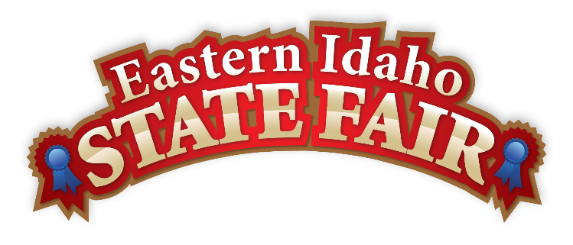
Media Contact
Brandon Bird
(208) 785-2480
brandon@funatthefair.com

FOR IMMEDIATE RELEASE

EISF names Karole Honas as 2022 Grand Marshal

BLACKFOOT, ID – JULY 23, 2022 - There are few, if any, more recognizable faces in Southeast Idaho than Karole Honas. Speaking from the television for 30 years on behalf of KIFI Local News 8 (and even years before that on KPVI), she represented our community as the voice of local news until her retirement in 2020. Based on her lifetime of dedication to the Eastern Idaho State Fair, the organization is proud to name Karole Honas as the 2022 EISF Grand Marshal.

When her old friend and co-anchor Jay Hildebrandt saw the open call for Grand Marshal applications, he knew he had to nominate Karole. Her live broadcasting from the fairgrounds spanned three decades, countless news stories, and, most likely, resulted in millions of interactions with the people of Southeast Idaho. Each year, people who watched her every night in their living rooms had the chance to meet her in person as she spent almost every day at the fairgrounds covering the news.

"When I started in the business 40 years ago, we shot everything on 16 mm film, which required heavy equipment that had to be hauled in and out of the fairgrounds, which was exhausting," says Honas. "We went from film to ENG. Electronic news gathering equipment. It meant carrying a heavy deck on your left shoulder, a big camera on your
right, and a heavy battery belt around your waist. That's when I asked for a llama! Every story required so much energy that we would cap it at 2 or 3 a day. The last year I worked the Fair, I shot five stories in one day on a cell phone that fit in my pocket."

Producing live TV in an environment such as the EISF can create its fair share of bloopers, as Karole discovered. Not realizing that she was already on, she did a lipstick check by putting her finger in her mouth and quickly pulling it out, much to the amusement of the viewers at home.

"From then on, people joked with me that the fair must be finger-licking fun," says Honas. "You can never be afraid to laugh at yourself."

The Eastern Idaho State Fair also contributed to an impactful memory that has lived with Honas to this day. After a long day on the fairgrounds, she joined a cowboy sitting on the bench outside of the Antique Barn. She asked if he was saving a seat, and he said no and that she would be more than welcome to sit. They sat together under the warm sun and had a casual conversation that lasted just a few minutes. The next day, Honas learned that the man had come to the EISF to spend his last day on Earth before taking his own life. Their interaction had given him enough hope to make a different choice and not go through with his intended plan.

"That experience had a huge impact on my life. I wonder what would have happened if I had been grumpy or avoided a conversation," says Honas. "It profoundly changed the way I lived, especially how I interact with strangers."

As anyone who's been to the Fair knows, it can be a messy event. During his first year at the Fair, Chief Meteorologist Michael Coats had joined Honas at the Fair for the day. He stood by in horror as an excited fan ran up and gave Honas a huge hug, momentarily forgetting she was covered in mustard, which quickly transferred to Honas' shirt. He couldn't believe that he had witnessed such a physical display of fandom.

"Michael was so shocked that someone would not only hug me but do it covered in mustard," laughs Honas. "I told Michael that when you cover the Fair in SE Idaho, you hug people. That's what our community does. I have a hugging aura about me anyway, so people always wanted to hug me."

"Karole always brought an element of excitement to the fairgrounds just by being there," says General Manager Brandon Bird. "Her dedication helped bring the Fair to life to people on days they couldn't attend. We'll always be grateful for the energy and personality she brought to the Fair as she covered the memorable stories of the Fair. She is a great person, and we are grateful she has been such a great contributor to our community."

Honas is currently enjoying her retirement with her husband and spending a lot of time volunteering at Champ's Heart in Idaho Falls.

"Retirement has been fun but very different. I'm used to being able to call anyone and say, 'I'm Karole Honas with Local News. Can you tell me what's going on?"' laughs Honas. "Now, I don't have the credentials, so I have to wait to see it on the news."

These days, Karole will still enjoy the Fair as a spectator and, this year, as the 2022 Eastern Idaho State Fair Grand Marshal. If you're lucky, you might catch her in the Tiger Ear line, and chances are she'll be just as friendly as she always was on TV.

"I always took great pride in being in a position to promote the Eastern Idaho State Fair. My town, my county, and encouraging people to come to the great 'family' reunion, which is the Fair, made me happy and feel like I was contributing to my home," says Honas.

The Eastern Idaho State Fair will run September 2nd-10th in Blackfoot, Idaho.

###

The Eastern Idaho State Fair is a 16-County Fair District. It is Eastern Idaho's longest-running and largest community event with nearly 250,000 attendees each year. The mission of the EISF is to provide wholesome, affordable family education and entertainment in a clean and safe agricultural environment. It is never too early to get excited for the 2022 Fair, which will be held September 2-10, 2022!

