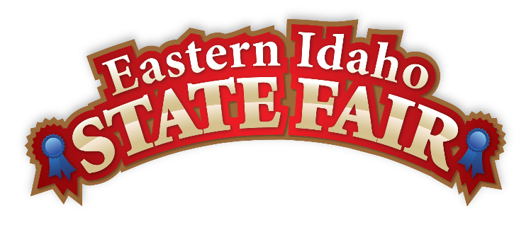
Media Contact
Brandon Bird
(208) 785-2480
brandon@funatthefair.com

FOR IMMEDIATE RELEASE

Eastern Idaho State Fair Unveils 2026 Theme, Star-Studded Lineup, and Grandstand Events

BLACKFOOT, ID – April 21, 2026 – The Eastern Idaho State Fair returns September 4–12, 2026, and this year, it's all about red, white, and blue. Fairgoers are invited to dust off their denim and wave their flags high as the 124th annual fair celebrates with a bold patriotic theme: "Red, White and Blue Jeans." As America marks 250 years, there's no better place to celebrate the spirit of 1776 than right here in Blackfoot.

This year's fair blends hometown tradition with big-name entertainment, all set against a backdrop of community pride, agriculture, and good old-fashioned fun. From live music and rodeo action to free entertainment and fair food favorites, there's something for everyone to enjoy.

All grandstand events will take place at the Bank of Commerce Grandstand, featuring a powerhouse lineup of entertainment throughout the week:

- Friday, September 4 - Flo Rida
- Saturday, September 5 - Bull Riding Championships
- Sunday, September 6 - Western Truck and Tractor Pulls
- Monday, September 7 - Gem State Class Pro Rodeo
- Tuesday, September 8 - Gem State Class Pro Rodeo
- Wednesday, September 9 - Gem State Class Pro Rodeo
- Thursday, September 10 - Gabriel Iglesias
- Friday, September 11 - Nate Smith
- Saturday, September 12 - September Slam Demolition Derby

In addition to grandstand events, fairgoers can expect a wide variety of free entertainment, exhibits, and attractions happening daily across the fairgrounds. Plus, all the classic fair food favorites make the Eastern Idaho State Fair a must-attend tradition for the entire family.

The 2026 fair is made possible in part by Grand Champion Sponsors Bingham Healthcare and Teton Auto Group, whose continued support helps bring top-tier entertainment and experiences to Eastern Idaho.

Tickets for grandstand events will go on pre-sale for VIP members on April 22 at 8:00 AM, with sales opening to the general public on April 24 at 12:01 AM. Fans can secure early access by joining the FREE VIP Club at www.funatthefair.com, where they can register their email to get a chance at the best seats in the house and receive the Fair's newsletter, exclusive offers, and special giveaways.

"The Eastern Idaho State Fair has always been a celebration of who we are — our community, our heritage, and the traditions that bring us together," said Brandon Bird, General Manager. "With America celebrating 250 years, we're thrilled to bring a fair experience that honors our past while delivering nine days of unforgettable entertainment."

Additional details, including daily schedules and attractions, will be released in the coming months. For more information, visit funatthefair.com.

###

The Eastern Idaho State Fair is a 16-County Fair District. It is Eastern Idaho's longest-running and largest community event, with over 250,000 attendees each year. The mission of the EISF is to provide wholesome, affordable family education and entertainment in a clean and safe agricultural environment. It is never too early to get excited for the 2026 Fair, which will be held September 4-12!

