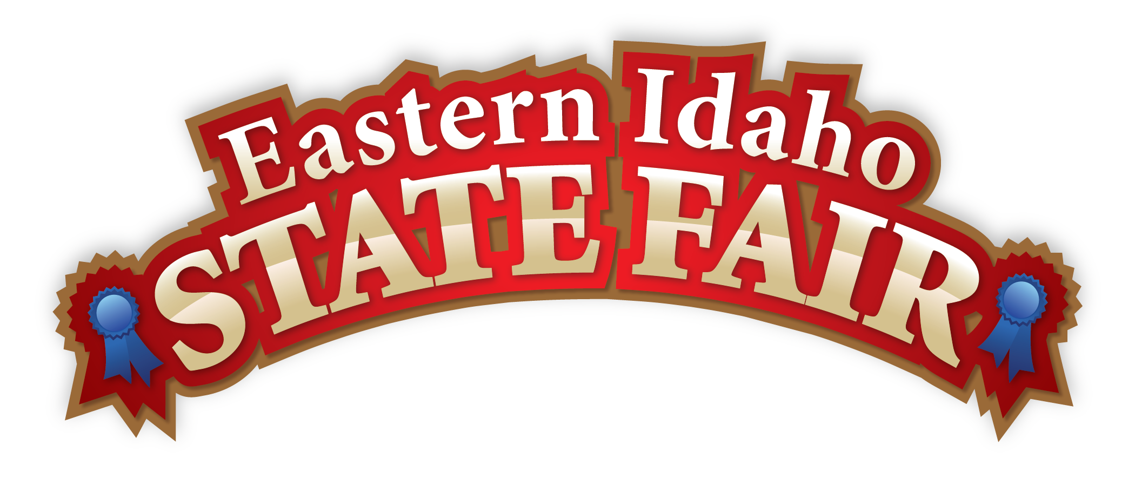
Media Contact
Brandon Bird
(208) 785-2480
brandon@funatthefair.com
FOR IMMEDIATE RELEASE
Eastern Idaho State Fair Closes with 5th Straight Year Over 250,000 Guests. Flo Rida Sets Opening-Night Attendance Record as America 250 Celebration Draws Historic Crowds
BLACKFOOT, ID, The Eastern Idaho State Fair wrapped up its 2026 season by welcoming 253,906 guests through its gates during its nine-day run from September 4 through 12.
Themed “Red, White and Blue Jeans” in celebration of America’s 250th anniversary, the 2026 event solidified its status as the region's premier community tradition. This marks the fifth consecutive year the Fair has surpassed the quarter-million-attendance milestone, pairing classic agricultural roots with a surging wave of national patriotism.
A Record-Setting Opening Night
The Fair exploded out of the gate with a historic start on Friday, Sept. 4. Chart-topping artist Flo Rida took the grandstand stage, drawing the largest opening-night crowd since the Fair expanded to its current nine-day format. The record-breaking concert set a high-energy tone for a week of standout entertainment and community celebration.
New Traditions and All-American Spirit
Patriotism was woven into every midway, marquee, and main stage as the Fair honored the nation's semiquincentennial. In a breathtaking display of American spirit, the Navy Leap Frogs Parachute Team free-fell into the Bank of Commerce Grandstand, flying the American Flag to kick off the Gem State Classic Pro Rodeo on Tuesday night.
Marking another milestone, the Fair successfully debuted its first-ever collectible pin drop, establishing a new keepsake tradition to commemorate the milestone year.
National Indian Relay Championship
As one of the most culturally significant and thrilling sporting events in the West, the National Indian Relay Championships saw 23 elite teams compete for the ultimate title. Following five days of high-intensity racing, Birdinground Team emerged victorious and was crowned the 2026 National Champion.

An Economic Engine for Eastern Idaho
Fair officials also hosted a press conference to unveil the findings of an independent fiscal study conducted by Chicago-based Johnson Consulting. The data confirmed the immense financial ripple effect the event has on the local community:
- $74.3 Million Total Impact: Generated by the annual nine-day Fair alone on the local economy.
- Job & Wage Support: Fair activity sustains approximately 600 ongoing jobs and $25.2 million in wages.
- Tourism Surge: Out-of-town visitors generated roughly 2,400 hotel room nights and $2.0 million in state and local tax revenues.
- Year-Round Reach: When accounting for off-season facility usage, the fairgrounds' total annual economic impact climbs to $82.5 million, supporting 660 jobs and $28.0 million in wages.
“These numbers confirm what we’ve always known to be true: the Fair isn’t just a beloved tradition; it’s an economic lifeline for Blackfoot and all of eastern Idaho,” said Brandon Bird, General Manager of the Eastern Idaho State Fair. “Our vendors, concessionaires, service providers, and staff are our neighbors and friends. Every ticket sold, every corn dog ordered, and every blue ribbon awarded ripples directly back into our local economy.”
Same Traditional Dates in 2027
Fair leadership confirmed that future scheduling will remain true to heritage, opening annually on the Friday before Labor Day. The 2027 Eastern Idaho State Fair will run from September 3 through 11, 2027, marking a monumental 125-year tradition.
“Our timing is part of our identity,” Bird added. “Families across eastern Idaho build their end-of-summer schedules around this Fair, and we are proud to keep that tradition exactly where it belongs.”
About the Eastern Idaho State Fair
The Eastern Idaho State Fair is a beloved regional tradition, drawing hundreds of thousands of visitors each year for nine days of food, entertainment, agriculture, competition, and community celebration. Located in Blackfoot, Idaho, the Fair has been a cornerstone of eastern Idaho culture for more than a century. The mission of the EISF is to provide wholesome, affordable family education and entertainment in a clean and safe agricultural environment. It is never too early to get excited for the 2027 Fair, which will be held September 3-11, celebrating 125 years of Tradition!
###

